HomeWork 4

Due Date: Wednesday 4/14/2021
HW Delivery: submit on Canvas by the due date, before midnight
Total Points: 60

General Rules: Create homework, compose specifications or any text by using a common document-creation tool, such as Microsoft® Word. Each HW question is worth 3 points.

1. What is essential to “defensive programming”?
There are a couple of essential considerations when programming defensively. First, protecting the user from both the program’s errors and the developer’s errors. Second, making sure it is impossible to receive bad input by removing ambiguities in the software’s UI and code.

2. List 3 simple-sounding Math problems (known from ancient times) known to be unsolvable geometrically.
The Squaring the Circle problem: Can you draw a square that contains the same area as any randomly constructed shape?
The Angle Trisection problem: Can you cut an angle into equal thirds using only a straightedge and a compass?
The Cube Doubling problem: Given one cube, can you construct a second cube with double the volume of the original using only a straightedge and a compass?

3. Discuss whether the order of elements in a set is relevant. Is duplication of elements in a set relevant; provide a simple example pro or con. Can sets be infinite?
Since a set is defined as an unordered list of elements, the order of elements does not typically matter because numbers are represented the same no matter what order they are in. Duplicated elements are ignored and repetition is not relevant when constructing or analyzing sets. Sets cannot be infinite because they are defined as finite groups of information, thus they are not continuous (infinite).

4. State via a single phrase each, what is essential for the following classes of numbers: integer, real, natural, irrational.
Integer: Must be a whole number (positive or negative) containing no fractions or decimals.
Real: Can be concretely placed on a number line.
Natural: Must be a positive whole number.
Irrational: Cannot be represented as a fraction (π, √2, etc.)

5. Argue the following claim: “It is possible to create SW that can correctly translate all English language sentences into corresponding French!”
I would argue that this is not possible because of cultural and societal differences in how people speak. English speakers (especially in America) use slang, nomenclatures, and other linguistic factors that drastically change over time. It would be a miracle of science if an algorithm could adapt to fully understand what every person was saying and translate it perfectly to another language. For example, French lacks vocabulary to translate certain English words over cleanly, just as English lacks vocabulary to translate certain French words cleanly.

6. When can it be still meaningful to use a linear search algorithm?
It would be meaningful to use a linear search when the set of information you are searching through is generally small or concise. Because it is very cut and dry, linear search is usually less preferable to other algorithms but in this case, it does just fine.

7. Argue pro or con: It is always better (for performance) to store data in a tree than in a linked list, when the number of lookups is very large, e.g. > 10⁹
I would argue against the notion that trees are the best way to store data. If the tree is unbalanced or unsorted, the search could be significantly more costly than just searching a linked list of data using your favorite algorithm.

8. Write in a common, high-level programming language the algorithm for a binary search for int element n, assuming a sorted integer array named data[] of MAX elements.
Binary Search in Python (double-click code for text editor):
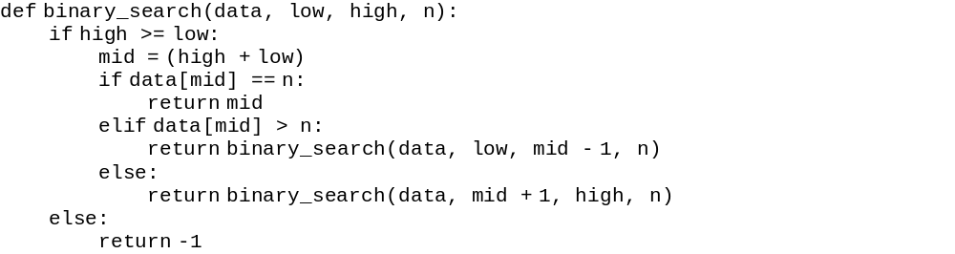

9. State what is essential to the general data structure: directed graph.
A directed graph G = (V, A) must contain a set of elements (nodes) with directional pointers (edges) and have defined destinations.

10. While searching for information in a graph G, the connectivity of nodes for G may lead the search back to a node previously visited. Suggest a programming method that avoids repeated visits to the same graph nodes.
One solution is to utilize a stack where each element inserted onto the stack should be unique. Every time you check a new node, also check that this element does not already exist within the current stack. If it does, skip checking that element; if it does not, insert it onto the stack of checked elements and continue.

11. According to CS researcher Tony Hoare, SW with real value should exhibit which attributes? List at least 5.
1) It should be secure.
2) It should be error-free.
3) It should be simple, yet effective.
4) It should use a well-constructed programming language.
5) Its source should be well-documented for future programmers.

12. Define Sequence. Does order matter in a sequence? Is repetition allowed and significant in a sequence? Give an example for arithmetic sequence.
A sequence is an ordered list of elements where repetition is relevant and is not ignored. An example of an arithmetic sequence is: 1, 3, 5, 7, … , n+2

13. Floating point numbers need a sign bit; plus the exponent can be positive or negative, or 0. IEEE 754 format for 64-bit floating point numbers defines just 1 dedicated sign bit. Explain how both sign questions are resolved.
The IEEE 754 format uses both single and double-precision formats to account for the use of exponents and positive/negative/zero values. It automatically reserves 11 bits to hold exponent values, 52 bits to hold positive/negative values, and 1 bit for the signed bit = 64 bits in total.

14. Given a literal with significant digits 12345. How does a high-level programming language identify the intended base? Choices for base are: 8, 10, or 16.
A high-level programming language determines the intended base by calculating the minimum number of bits it would require to represent a certain number. For example, the minimum number of bits to represent 12345 is 16, so it would use base 16.

15. Convert decimal 27411 to binary, octal and hexadecimal. Is this integer number representable on an ancient 16-bit, Twos-Complement architecture? What is the bit pattern for its negative value in Twos-Complement representation?
Binary: 110101100010011
Octal: 65423
Hexadecimal: 6B13
Two’s Complement: 0110101100010011

16. Argue pro or con: “Program PRIME that computes the first million prime numbers lacks input. Thus it is NOT an algorithm! It lacks input!”
I would argue against this claim because an algorithm does not necessarily need input in order to be considered algorithmic. You can construct a general formula or set of instructions to aid in finding general solutions to things without there being any input for some value X. Like the algorithm to convert ASCII characters into binary, decimal, hexadecimal, etc., does not immediately require input but rather it provides a clear set of instructions on how to about it.

17. List and explain at least 5 characteristics that SW with true value should exhibit.
- Future-proof, well-documented, and maintainable for future programmers.
- Ease of access for the client/user.
- Should serve exactly the intended purpose.
- Programmed defensively to prevent both user and programmer errors.
- Simple to read/edit for any programmer reading the source.

18. Using integer computation, what is the correct integer quotient and (if applicable) the integer remainder of: -15 / 6? What is a necessary requirement for the remainder in integer division?
There are two necessary requirements for the remainder when using the modulus operator. First is to ensure that it is saved with a signed bit if the result is negative, and second is that it has a proper storage location.

19. Prove that the sum of all a^{j} with j=0..n = (a^{j+1} - 1) / (a - 1).
Skip

20. State the key difference between a Recurrence Relation and a Recursive Definition.
A recurrence relation does not require an initial value/condition but recursion does.

